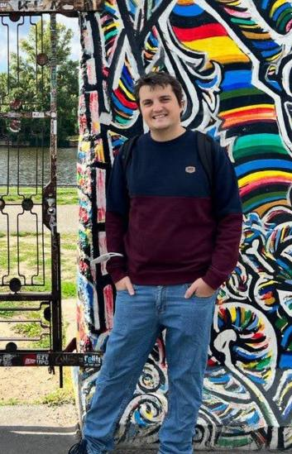 |  | Bontempo Gianpaolo  PhD student
Skills  Summary :  As a dedicated researcher on deep vision, my work focuses on two crucial areas: Multi-Instance Learning (MIL) for Whole Slide Image (WSI) classification and Neuro-Symbolic Continual Learning for high-level concept mapping and consistent reasoning.  Contacts  Email: g.bontempo@studenti.unipi.it  Website  Linkedin |  | Education  University of Pisa  2021 - Present  PhD in national artificial intelligence  Politheclic of Turin  2017 - 2020  Master degree: 108/110  Professional Experiences  IIT, Research Fellow  2020 – 2021  Tour guide robot: Deployment of behaviors trees on a robotic system for a museum tour  Pubblications  - E.Marconato, G.Bontempo, E.Ficarra, S.Calderara, A.Passerini, S.Teso. “Neuro Symbolic Continual Learning: Knowledge, Reasoning and Concept Rehearsal” (accepted at ICML)  - M.Lovino,G.Bontempo,G. Cirrincione, E. Ficarra. “ Multi-omics classification on kidney samples exploiting uncertainty-aware models.  - E.Marconato,G.Bontempo,S.Teso,E.Ficarra,S.Calderara,A. Passerini. “Catastrophic Forgetting in Continual Concept Bottlenect Models”.  - F.Citarrella, G.Bontempo, M.Lovino, E.Ficarra. “FusionFlow: an integrated system workflow for gene fusion detection in genomic samples”  - G. Bontempo, F. Bolelli, A. Porrello, E. Ficarra, S. Calderara. “DAS-MIL:Distilling Across Scales for MIL Classification of Histological WSIs.”(under review)  - G.Bontempo, L.Lumetti,A.Porrello,F.Bolelli,E.Ficarra. “Buffer-MIL: Robust Multi Instance Learning with a Buffer Based Approach (under review)

